FINAL PROJECT REPORT 2026
Youth Voices for Antimicrobial Awareness
Pilot phase: recruiting a youth volunteer base for AMR awareness
Project Lead: Tehzeeb Liaqat, Pharm.D Graduate, Pakistan
Status: Pilot recruitment and impact assessment completed
Sample: 25 volunteer respondents across 4 countries
25  volunteer respondents | 4  countries | 52%  can give 2+ hrs/month | 76%  new to international projects

1. Summary
Antimicrobial resistance (AMR) is usually discussed as a clinical and policy problem. YVAA starts from a different question: who will carry the message to the public, and can young people do it? This pilot set out to answer the first step of that question by finding out how many young people were willing to volunteer, what skills they could offer, and how much time they could give.
Through an international volunteer-interest form, 25 people from Pakistan, the UK, the UAE and Saudi Arabia expressed interest. Most were undergraduates (64%), most had never worked on an international project (76%), and just over half (52%) could commit at least two hours a month. Health and science communication was the most requested role (13 of 25), well ahead of every other area.
What this report does and does not claim. The data measures stated interest, not delivered work. YVAA is an early-stage initiative with a baseline pool of volunteers and no large-scale impact yet.

2. Background and Objectives
YVAA began as a small international volunteer-interest survey, not as a formal organisation. The form was circulated to recruit youth interested in AMR communication, research, data, outreach and education. The pilot had five objectives:
- bring more young people into work on AMR;
- identify who is willing to volunteer, and in which functions;
- encourage multicultural collaboration among students and young professionals;
- test how youth can contribute across communication, research, data, outreach and education;
- lay groundwork for future campaigns and collaborations.

3. Method
A structured, self-reported online form was used. It collected country or background, status, prior international or multicultural experience, monthly availability, areas of contribution, and interest in future YVAA activities. The final sample was 25. No personal contact details appear in this report.
The survey was self-selected and is not representative. Country figures reflect who the form reached, not true proportions, and some respondents gave informal location terms (for example England/London or Dubai) which were grouped under the UK and UAE.

4. Findings

4.1 Where respondents are from
Country | Respondents | Share
Pakistan | 17 | 68%
UK | 4 | 16%
UAE | 3 | 12%
Saudi Arabia | 1 | 4%
Total | 25 | 100%

Pakistan dominates, which is expected given the project lead’s network, but 8 of 25 respondents (32%) came from outside the country. That is early evidence of interest beyond the founding community.

4.2 Who they are
Status | Respondents | Share
Undergraduate students | 16 | 64%
Master’s students | 3 | 12%
Recent graduates | 3 | 12%
Healthcare professional | 1 | 4%
Other | 2 | 8%
Total | 25 | 100%

The pool is overwhelmingly student-based. Only one healthcare professional responded, so clinical perspectives are thin and will need deliberate recruitment.

4.3 International experience
Prior international or multicultural project | Respondents | Share
Yes | 6 | 24%
No | 19 | 76%
Total | 25 | 100%

Three in four respondents have never done international project work. For them YVAA is a first step; for the six who have, it is a chance to apply experience. Mentoring between the two groups is a natural fit.

4.4 Time available
Monthly availability | Respondents | Share
2 hours or more | 13 | 52%
Other | 12 | 48%
Total | 25 | 100%

Thirteen people reported at least two hours a month. This is self-reported and should be read as a potential pool, not a confirmed roster. The “Other” group was not broken down, so it may include people with less time or simply different answers.

4.5 What they want to contribute
Respondents could choose several areas, so totals exceed 25.
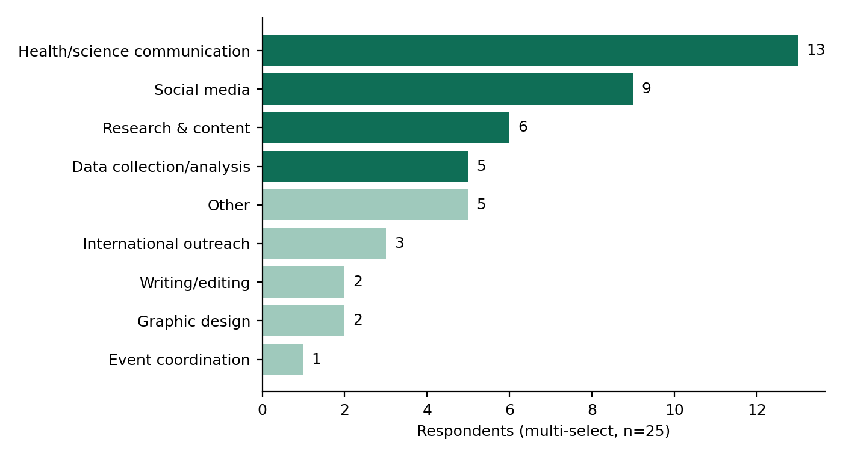
Four areas stand out: health/science communication (13), social media (9), research and content (6) and data collection/analysis (5). Event coordination (1), graphic design (2) and writing/editing (2) are almost uncovered. Communication-heavy interest and thin design capacity suggest the first campaigns should be text- and discussion-led, with design support sourced elsewhere until more designers join.

5. Project Structure
Project material was organised into seven sections so that evidence builds up in one place: Concept Note, Team, Educational Content, Surveys & Data, Events, Final Report, and Evidence for CV. The last section lets volunteers keep a record of their contribution, which supports retention.

6. Limitations
- Small sample (N=25), so percentages move a lot with one person.
- Self-selected respondents; no population can be inferred.
- Two-thirds are from Pakistan.
- Interest was measured, not actual contribution.
- The “Other” availability group is not specified.
- No long-term effect on AMR awareness can be assessed at this stage.

7. Recommendations

Educational content
Train volunteers first. Start with AMR basics, antibiotic misuse, antimicrobial stewardship, appropriate antibiotic use, and One Health, so that public messaging rests on accurate shared knowledge.

Youth engagement
Build teams around demonstrated interest: a communication team, a research and content team, a social media team, and a data team, with outreach support. Recruit actively for design, writing and healthcare professionals.

Evidence collection
Track from the start: volunteer numbers, educational materials produced, social media engagement, events held, countries reached, and what each volunteer contributed.

Evaluation
Repeat a survey after the first activities to measure change in AMR knowledge, volunteer learning and engagement, the impact of awareness content, and volunteer retention. Compare against this baseline.

8. Conclusion
The pilot achieved what it set out to do: it showed that young people in several countries are willing to volunteer on AMR awareness and identified what they can offer. 25 volunteers from 4 countries, a clear lead interest in science communication, and a 13-person group with at least two hours a month form a workable starting base.
The next phase is where YVAA has to prove itself. The priority is converting expressed interest into published educational content and documented activity, measured against the baseline in this report.

